**Experiment No. 5**

**Aim: Data Analytics II**

**Problem Statement:**

1. Implement logistic regression using Python/R to perform classification on

Social_Network_Ads.csv dataset.

2. Compute Confusion matrix to find TP, FP, TN, FN, Accuracy, Error rate, Precision, Recall on

the given dataset.

**Theory:**

Logistic regression is one of the most popular Machine Learning algorithms, which comes under the Supervised Learning technique. It is used for predicting the categorical dependent variable using a given set of independent variables.

Logistic regression predicts the output of a categorical dependent variable. Therefore the outcome must be a categorical or discrete value. It can be either Yes or No, 0 or 1, true or False, etc. but instead of giving the exact value as 0 and 1, **it gives the probabilistic values which lie between 0 and 1**.

Logistic Regression is much similar to Linear Regression except that how they are used. Linear Regression is used for solving Regression problems, whereas **Logistic regression is used for solving the classification problems**.In Logistic regression, instead of fitting a regression line, we fit an "S" shaped logistic function, which predicts two maximum values (0 or 1).The curve from the logistic function indicates the likelihood of something such as whether the cells are cancerous or not, a mouse is obese or not based on its weight, etc.

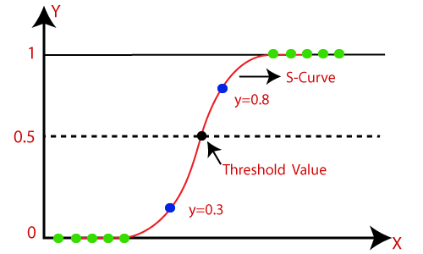

Performance measurement for machine learning classification problems where output can be two or more classes. It is a table with 4 different combinations of predicted and actual values.

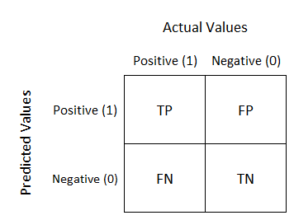

It is extremely useful for measuring Recall, Precision, Specificity, Accuracy, and most importantly AUC-ROC curves.

**True Positive:**

Interpretation: You predicted positive and it’s true.

**True Negative:**

Interpretation: You predicted negative and it’s true.

**False Positive: (Type 1 Error)**

Interpretation: You predicted positive and it’s false.

**False Negative: (Type 2 Error)**

Interpretation: You predicted negative and it’s false.

**Recall**

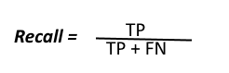

The above equation can be explained by saying, from all the positive classes, how many we predicted correctly.

Recall should be as high as possible.

**Precision**

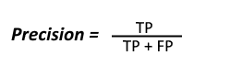

The above equation can be explained by saying, from all the classes we have predicted as positive, how many are actually positive.

Precision should be as high as possible.

**Accuracy**

how many of them we have predicted correctly.

Accuracy should be as high as possible.

**F-measure**

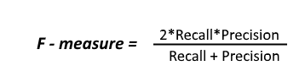

It is difficult to compare two models with low precision and high recall or vice versa. So to make them comparable, we use F-Score. F-score helps to measure Recall and Precision at the same time. It uses Harmonic Mean in place of Arithmetic Mean by punishing the extreme values more.

**Conclusion:** Hence we have computed a confusion matrix for accuracy, recall on a given dataset.